MEDIATOR’S INFORMATION

PHAM QUY TY |  | 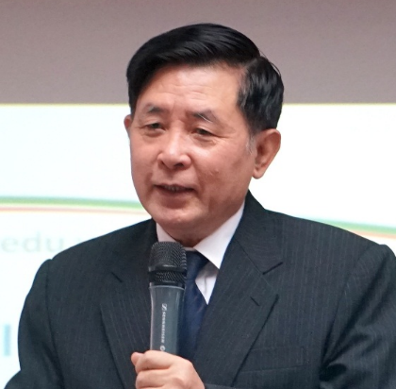
Former Deputy Minister, Ministry of Justice
Hanoi
Tel: | Fax:
Email: typhamquy@yahoo.com.vn
Fluent in English
Training
Doctor | Institute of Law – Vietnam Academy of Social Sciences
Career
Working as: the Procurator, Judge
Participating in: State Economic Arbitration, Law Making, State Administration
Director of 02 ministerial-level projects
Participating in some state and ministerial-level projects

